DSA Mini Project

VIT Chat Bot

Team members::

1)Sanjay Vikas SM(22BAI1071)

2)Suriya S(22BAI1323)

3)Kishore Kumar V(22BCE5121)

**AIM**

To provide the complete answer given by the user.

**Abstract**

The "VIT Chat Bot" mini-project has a primary objective of creating an intelligent conversational agent to foster seamless communication and information dissemination within the Vellore Institute of Technology (VIT) Chennai campus community. This chatbot is specifically tailored to cater to the needs of students, faculty, and staff, addressing a wide array of inquiries spanning campus facilities, events, academic details, administrative procedures, and general questions.

Utilizing cutting-edge natural language processing (NLP) techniques, the VIT Chat Bot will provide an interactive and user-friendly platform for engaging in text-based conversations. It harnesses the power of NLP to recognize the intent behind user queries, extract relevant entities, and offer predefined responses. In doing so, the chatbot aspires to make information more readily accessible and reduce reliance on manual assistance. This, in turn, promises to elevate the efficiency and effectiveness of communication within the campus environment.

The VIT Chat Bot serves as a technological bridge, connecting the campus community to the wealth of knowledge and services available at VIT Chennai. Its proficiency in language understanding and contextual awareness enables it to be a reliable source of information and assistance, ensuring that students, faculty, and staff can easily find answers to their questions and stay informed about important events and resources on campus. Ultimately, the VIT Chat Bot is poised to significantly enhance the overall campus experience through seamless, AI-driven communication.

**Introduction**

In an era defined by rapid technological advancements, the integration of Artificial Intelligence (AI) and Natural Language Processing (NLP) has revolutionized various facets of our lives. One such remarkable application is the development of Chatbots – intelligent conversational agents designed to interact with humans in a manner that simulates natural human conversation. Among these innovative implementations, the VIT Chatbot stands as a shining example of cutting-edge technology harnessed for the betterment of academic institutions. IT Chatbot is an advanced AI-powered system tailored specifically for Vellore Institute of Technology (VIT), a renowned educational institution with a global presence. Established with a mission to provide world-class education, VIT continually seeks innovative ways to enhance the learning experience for its students and streamline administrative processes. The VIT Chatbot is a testament to the institution's commitment to embracing technology to improve communication, accessibility, and efficiency.

This intelligent virtual assistant is designed to assist students, faculty, and staff members in navigating the extensive resources and services offered by VIT. Leveraging state-of-the-art NLP models, the chatbot is capable of comprehending natural language input, enabling users to interact with it in a conversational manner. Whether it's inquiring about course schedules, accessing academic materials, or seeking information on campus facilities, the VIT Chatbot provides prompt and accurate responses, significantly reducing the time and effort required for these routine tasks.

The VIT Chatbot offers a multitude of functionalities tailored to meet the diverse needs of the VIT community. Students can easily obtain information about course registration, exam schedules, and academic deadlines, allowing them to manage their academic responsibilities more efficiently. Moreover, the chatbot serves as a valuable resource for accessing study materials, lecture notes, and other academic resources, empowering students to excel in their studies. Faculty members also benefit immensely from the VIT Chatbot, which provides them with quick access to administrative information, research resources, and campus events. Whether it's scheduling meetings, reserving facilities, or staying updated on important announcements, the chatbot streamlines these processes, allowing faculty members to focus more on their core responsibilities.

Administrative staff find the VIT Chatbot to be an indispensable tool in managing the operational aspects of the institution. From handling inquiries about admissions and fee structures to providing information on campus events and facilities, the chatbot serves as a reliable point of contact for both internal and external stakeholders.

One of the key strengths of the VIT Chatbot lies in its adaptability and continuous improvement. The system is equipped with learning capabilities, enabling it to analyse user interactions and refine its responses over time. This iterative process of learning and adaptation ensures that the chatbot remains up-to-date with the evolving needs and requirements of the VIT community.

In conclusion, the VIT Chatbot stands as a testament to VIT's dedication to leveraging technology for the betterment of its academic community. By providing a user-friendly and efficient interface for accessing information and services, the chatbot not only enhances the overall experience for students, faculty, and staff but also exemplifies VIT's commitment to innovation and excellence in education. As technology continues to advance, the VIT Chatbot serves as a shining example of how institutions can harness the power of AI and NLP to transform the way they interact with their stakeholders, ultimately fostering a more informed, engaged, and empowered academic community.

**Architecture Diagram**

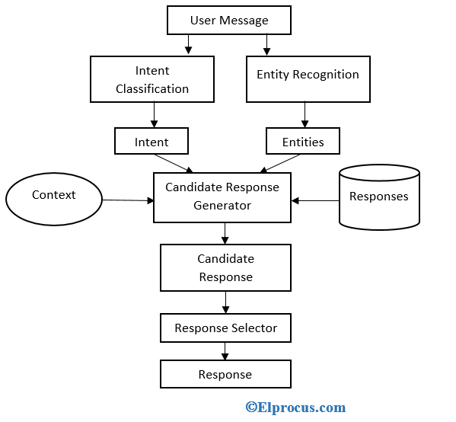

**Process Flow**

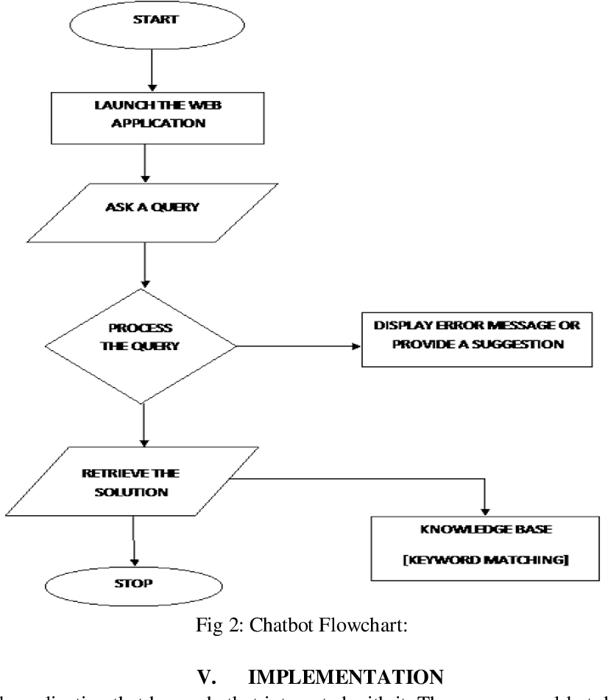

**Database**

 

**Experiment setup**

PyCharm Community Edition 2023.2.1

**Result**

